June 27, 2024

kiran jais chemmanatte

RMIT University

S3988985@student.rmit.edu.au

Motor log DASHBOARD

Utilizing Power BI to create AND SHARE A DASHBOARD

Table of Contents

Introduction

Objectives

Tasks and Observations

Data sources

References

Introduction

1. Power BI: Power BI is a business analytics tool developed by Microsoft. It allows users to visualize data, share insights across an organization, and embed analytics into applications. Power BI can connect to various data sources, transform data, and create interactive dashboards and reports. It's widely used for data-driven decision making in businesses of all sizes.
2. Microsoft Teams : Microsoft Word is a versatile word processing software developed by Microsoft Corporation. It allows users to create, edit, and format text documents with ease. Word offers a wide range of features including spell check, grammar correction, and various formatting options for text, paragraphs, and pages. The software supports the insertion of images, tables, and other media, making it suitable for creating professional documents, reports, and even simple desktop publishing projects. With its user-friendly interface and regular updates, Microsoft Word remains one of the most popular tools for document creation in both personal and professional settings.

Objectives

The Main objective here is to provide a vibrant and useful dashboard which ingests and visualizes Motor vehicle logs for the client.

The user requires comparisons regarding the performance in terms of kilometers run, petrol consumed, deliveries made and revenue made on a week by week basis. To compare and contrast the performance.

The visual aspect is key, hence strong personalized visuals with attention to detail is required.

The user has minimal knowledge of Power BI and technology in general, so the product is designed in a way which minimizes the onboarding effort required.

Consult with the client to understand user requirements and fulfill the requirement to the best and to the extent of possibility.

Create a user manual or product guide to transition the client to smooth usage of the product

Tasks and Observations

Task 1: Consult with the client and figure out project requirements.

Post consulting with the client, it was known that the client keeps a paper record of the data and would like to summarize and obtain useful metrics and indicators from that data source.

The main metrics that the client needs are deliveries made, kilometers travelled, petrol consumed, and revenue collected on a week-by-week basis.

Another key insight was the fuel economy information of the car, which was source with information from both the client and google and was fixed at 15.1 km /liter

Task 2: Data source design

The data source is a google sheet excel file hosted on the cloud , the file is made private with access only provided to the developer and the user .

The excel is a single sheet with 7 columns resembling the paper based record system used by the client.

Figure 1 : Schematic of the excel sheet

The excel sheet has 7 columns, them being date, sales (amount of money made on the day), purpose , starting odometer reading , finish odometer reading , kilometres travelled and finally number of deliveries . The link to the file is provided in the. Data sources.

Task 3 : Data modelling

The model requires two pages , the first page contains information on the main metrics that the client needs are deliveries made, kilometers travelled, petrol consumed and revenue collected on a week by week basis with previous week and current week.

First a calculated column in created which adds a column containing information on which week of the year we are currently on.

Week of year = WEEKNUM('MOTOR DELIVERY RECORD'[DATE],2)

The above code provides exactly that.

Next 8 measures are created to provide information on sum of deliveries etc of the previous week and the current week the code required to execute that is provided below.



Figure 2: Code to tabulate weekly date on of the current week.

Moreover, for the second page graphs which showcased bar charts that showcased deliveries make and revenue earned as a historical visual on a weekly basis was required.

It was easily delivered with the help of creating the weeknum calculated column.

Similarly the Dax used to obtain the measurement of weekly averages is as follows , it makes use of the calculate function .



Figure 3 : Dax to obtain the weekly averages

Task 4: Visual design

The following video was consulted to design the dashboard , it was customised according to the clients taste with a winnie the Pooh design.

The colour scheme was chosed with colours that mix well and blend with the background image utilizing the following [website](https://colorhunt.co/).

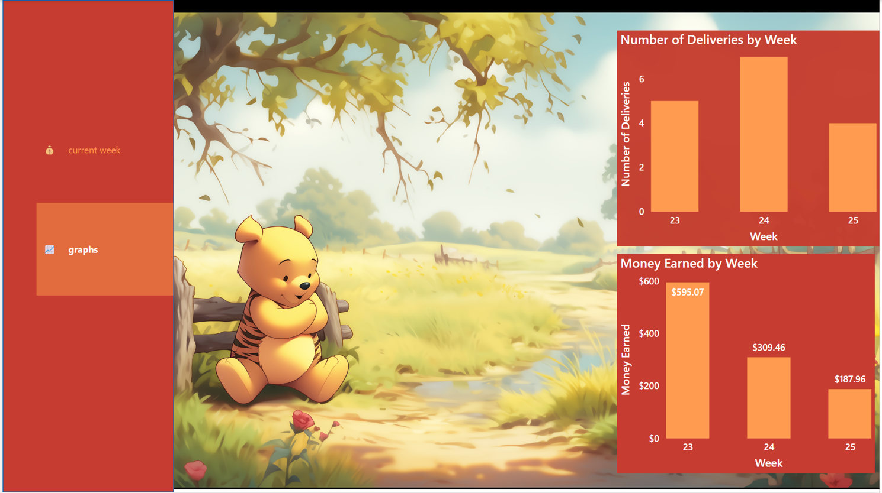

Figure 4: Colour scheme and background image design

The next key feature was the creation of the navigation bar, it can be found here

**Insert => Buttons => Navigator => Page navigator**

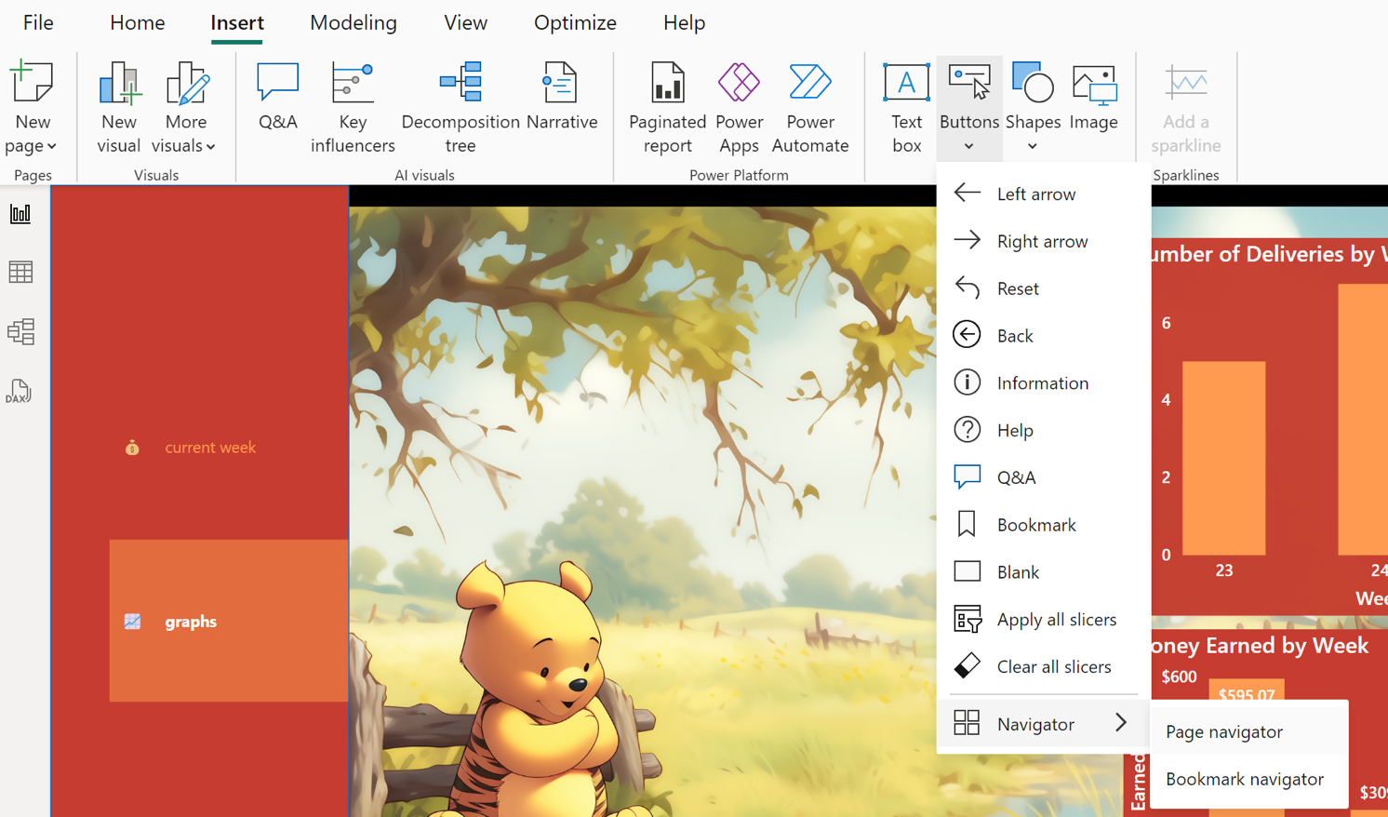

Figure 5 : Location of the nav bar in power bi

The main design flow is followed as per the video linked below.

[Dashboard design video](https://www.youtube.com/watch?v=-GCV4LvPMW0)

Moreover, the dashboard also include selected effects and on hover animations. The ascii used to customise the nav bar buttons is found here in this website.

Task 5: Dashboard sharing and post development plan.

The dashboard is published to power Bi service and scheduled refresh is set to 8 times a day to reduce downtime between data updating and result reflection on the dashboard.

The dashboard is shared on a teams page, and the client is invited to the page in question or the teams group to access the data . Moreover, access to the data source is provided to the user to modify and add data to the source.

Finally a user guide was created to assist the user with the product.

Data Resources

[Excel Sheet](https://docs.google.com/spreadsheets/d/1FT2eVwX4GF1rFyrj3QFrXBSLD4qoWh4Mf0IcN0DjRIY/edit?usp=sharing)

References